A NOVEL AC-DC CONVERTER TOPOLOGY FOR LOW ENERGY
HARVESTING

1) Shaik Rafi Ahmed, Asst. Professor, Deccan College of Engineering & Technology,
Hyderabad (shaikrafi_ahmed@yahoo.com)
2) Dr.Pannala Krishna Murthy, Swarna Bharathi Institute Of Science & Technology
Khammam (Krishnamurthy.pannala@gmail.com)
3)Dr.Sardar Ali Professor&Head of Dept,Royal instate of science &technology,Chevella.

Abstract: Low voltage micro generators requires higher efficiency which can be obtained by direct conversion of low ac input voltage to required high voltage dc output at higher efficiency. Ac-dc bridge converters may not be of practical use for operation of micro generators. This paper presents a novel ac-dc converter topology for low power harvesting where a boost converter is operated in positive half cycle and a buck-boost converter is operated in negative half cycle. For independent operation a self starting circuit is proposed and power parameters and duty cycle are used to operate and control the converter where detailed loss calculation of converter is carried out. Experimental results are also presented along with simulation. Design guidelines are presented for selecting the converter component and control parameters.

accordance with the consideration of the design parameters. The electromagnetic Micro generators typically consist of a moving permanent magnet, linking flux with a stationery coil. The variation of the flux linkage induces AC voltage in the coil. The typical output voltage of electromagnetic micro generator is sinusoidal. Hence, in this study, the micro generator is model as a sinusoidal AC voltage source. Furthermore, electromagnetic micro generators with low output voltages (few hundreds of milli volts) are only considered in this study for energy harvesting.

The pulse signal produced by the PWM is fed to the two buffers that can enabled by the external signals. The comparators in the polarity detector unit enable the appropriate buffers to produce gate pulses (v_{g1} andv_{g2}) that control IGBTs of the boost and buck-boost converter during appropriate half cycle. The gate triggering pulses are given by the fig.1
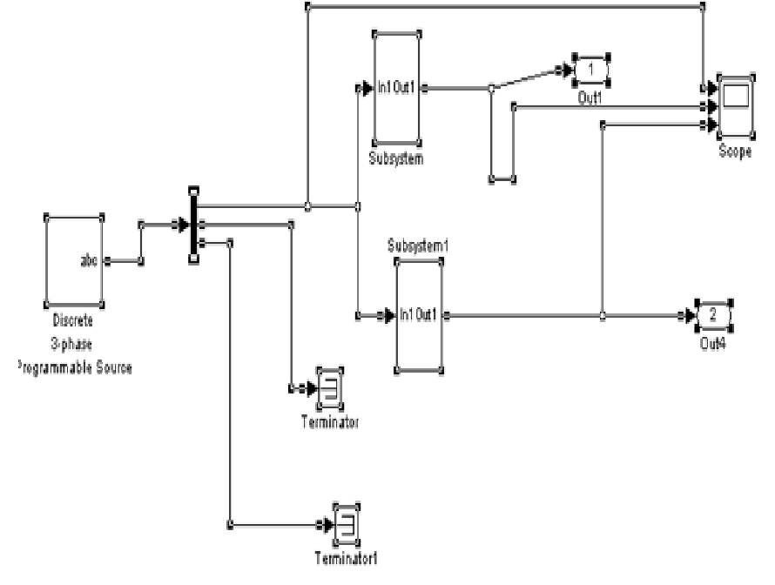

Keyword: Boost Converter, Buck converter and PWM

I. INTRODUCTION

The design aspects of the micro generator comprises spring, coil and rear earth magnet have been addressed. The theoretical analyses of the electromagnetic micro generator are established. Firstly, steady state analysis has been undertaken to determine the practical performance of the device. It is found that the generator will produce more power in applications with high frequency of vibration. Secondly, electromagnetic analysis is established to calculate the generated power on the load. It is found that the output power can be maximized when the impedance of the coil is less than the load impedance and when using a magnet with high magnetic field. Mechanical parameters like (damping factor, resonant frequency, proof mass and maximum displacement) and magnetic parameters like (load resistance, coil resistance, and the magnetic field) have been adjusted to optimize the output power through a comprehensive theoretical study. A range of micro generator output power values are obtained in

Fig.1 Triggering pulses to the buck and buck- boostconverter

The proposed direct ac-to-dc power conditioning circuit, as shown in Fig (1.3), consists of one boost converter in parallel with one buck-boost converter. The output capacitor C of this converter is charged by the boost converter (comprising inductor L1, switch S1, and diode D1) and the buck-boost converter (comprising inductor L2, switch S2, and diode D2) during the positive half-cycles and the negative half-

V_{ik} =
cycles of the sinusoidal ac input voltage (vi), respectively. IGBT is utilized to realize the switches

S1 and S2. It can be noted that the IGBT’s are subjected to reverse voltage by the ac output of the micro generator. To block the reverse conduction, the forward voltage drop of the body diodes of the IGBT is chosen to be higher than the peak of the input ac voltage. Two Schottky diodes (D1 and D2) with low forward voltage drop are used in the boost and buck-boost converter circuits for low losses in the diodes. It can be mentioned that the diodes can be replaced by the IGBT’s to further improve the efficiency of the converter. Individual gate Vg1,Vg2 pulses are given to the proposed AC-DC converter as shown in Figures 2 and 3.
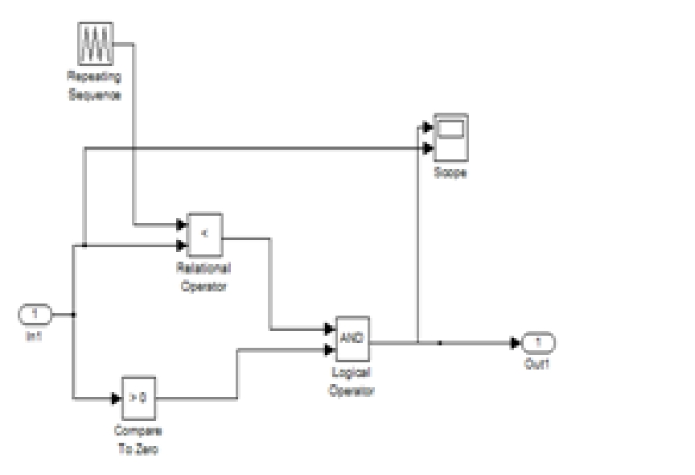

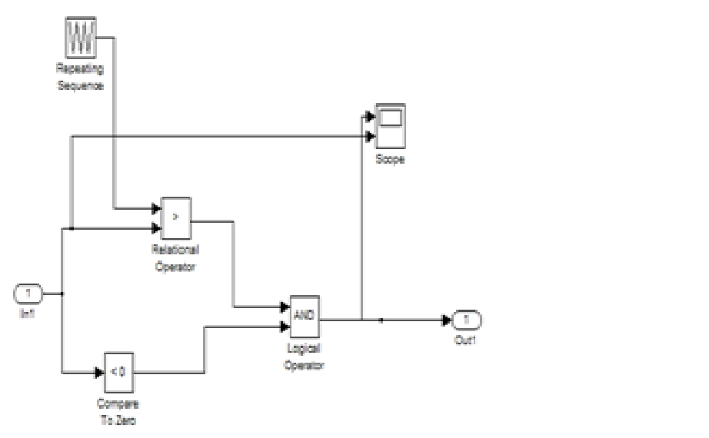
Fig: 2 Triggering Pulse Vg1 to the boost converter.

Fig: 3 Triggering Pulse Vg2 to the Buck-boost converter

The proposed converter is operated under discontinued mode of operation (DCM). This reduces the switch turn on and turn off losses. The DCM operation also reduces the diode reverse recovery losses of the Boost and Buck boost converter diodes. Furthermore the DCM operation enables easy implementation of the control scheme. It can be noted that under constant duty cycle DCM operation, the input current is proportional to the input voltage at every switching cycle; therefore the overall input current will be in phase with micro generator output voltage. The converter operation can be divided four modes.

Mode1 and Mode2 are the boost converter operation during the positive half cycle of the input voltage. Under Mode1 the boost switch S1 is ON and the current in the boost Inductor builds. During Mode2, the switched is turned Off and the output capacitor is charged. The other two modes: mode3 and mode4 are for the buck-boost converter operation during the negative half cycle of the input voltage. Under mode3 the buck-boost switch S2 is ON and the current in the buck-boost inductor builds. During mode4 the buck boost switch S2 is turned OFF and the stored energy of the buck-boost inductor is discharged to the output capacitor.

  - CONVERTER ANALYSIS
A. Operating Principle

Consider the input current wave form of the converter as shown in figure 2.4.It can be noted that during the boost converter operation, the input current I and the boost inductor current (iL1) are equal, but during the buck-boost converter operation, the input current I and the current in buck-boost inductor (iL2) are not equal. This is because, in the buck-boot converter the input current becomes 0 during the switch turn off period (T off).

Therefore, in a switching cycle, the energy transferred to the output by a buck-boost converter is equal to the energy stored in the inductor, whereas, in the boost converter, the energy transferred to the output is more than the energy stored in the inductor. Hence, for the equal duty cycles, input voltages and inductor values (L1=L2), the total powers delivered by the two converters over an input voltage cycle are not equal. In this paper, analyses of the converters are carried out and the relations between the control and circuit parameters of the boost and the buck-boost converters pertaining to the input power and the output power are obtained. Consider any Kth switching cycle of the boost and the buck-boost converter. Where Ts is the time period of the switching cycle, Db is the duty cycle of the boost converter, DfTs is the boost inductor current fall (are the diode D1 conduction time), Dc is the duty cycle of the buck-boost converter, Vi is the input voltage of the generator with amplitude Vp and Vo is the converter output voltage assuming the switching time period Ts of the converter is much smaller than the time period of the input ac cycle Ti, the peak value of the current inductor i_{pk} Where
Ipk = m1DbTs =VikDbTs
L1
Vp Sin (2∏kTs)
Ti

After the boost converter switch is turned OFF, the current in the inductor starts to fall. The slope ( m2) of this current is decided by the voltage across the inductor. In a kth switching cycle, the voltage across the inductor during the inductor current fall time is v0-vik.Therefore the inductor current fall time can be found as in
Df Ts = ipk / m2 = ipkL1 / Vo – vik

During this kth switching cycle, the total energy ( Ekb ) transferred from the input of the boost converter can be obtained as
Ekb = vikipk ( Db – Df ) / 2

The average power supplied in the boost switching cycle is
Pbk = Ek / Ts = vikipk (Db – Df ) / 2

The number of switching cycles during the time period of one input cycle is defined as N = Ti / Ts. In the proposed power electronics converter topology, the boost converter is operated for the half time period of the input ac cycle (Ti/2).

The key design steps for this converter are to select the IGBT’s inductors, and the switching frequency of the converter. For a given micro generator and a load, the input and output voltages are specified. Therefore, in this case, the voltage rating of the IGBT’s are decided by the output voltage of the converter. The current rating of the IGBT’s has to be decided by the designer. It can be noted that the IGBT carries maximum current at the peak of the input voltage. The maximum current I _{max} of the convert can be obtained as in where f s is the switching frequency of the converter, L is the inductance value for both boost and buck-boost converters, and D is the duty cycle of the converters (D=d_{b}=d_{c})

Filter capacitor value can be decided by using following formula:

Cf = 5i/ (Vpeak*f) Cf = filter capacitor
Vpeak =50V, f=frequency=50Hz, Cf=12000uf

In this paper we are using two 4700uf electrolytic capacitors are used in parallel. Generally for 1A current 2000uf electrolytic capacitor is used.

Choosing the Right Capacitor: For power source filtering, we use electrolytic capacitors, because we need capacities from hundreds to thousands of microfarads (uF), and only electrolytic capacitors cover this range. They have polarity, which it is usually identified at least on the negative terminal, with the minus symbol (-).

One particularity about these capacitors is that most of the electronic components do not suffer the passage of the time, but electrolytic capacitors do. After five to ten years their fault probability sensibly tends to grow. For defining the appropriated capacitor parameters for our application, we need the rectifier voltage, the output current and the maximum admissible ripple. For example, we have a 110 to 12VAC transformer, a diode bridge rectifier, and a maximum load current of 0.5Amp. Let’s assume that the circuit we are going to feed requires that V (ripple) is not more than 2 volt. We use the previous formula but reordered in this way.
C =I/ (2*f*VF)=0.5/ (2*50*2) =2100uF

The nearest available size is 200uF. Now we need to know which is the maximum voltage that the capacitor is going to be exposed to. We must

consider the worst case, this is the V (rectified) peak in no-load condition, what means without deducting the voltage drop on diodes:
V_{peak}=V*√2 = 12*1.41 =17 Volt

Available commercial values are 16V, 25V, 35V, 50V, 63V. 25V is ok for our application. So, our capacitor is completely defined as “Electrolytic capacitor 220uF x 25V”
B. Control Circuit

In a practical energy-harvesting scenario, the controller and the IGBT driver circuit of the converter are required to be self-starting and they should be powered by the energy harvesting system. An auxiliary self-starting circuit is proposed to power the controller and the drivers at the beginning, when the converter starts up. The proposed self-starting auxiliary circuit utilizes a battery and schottky diodes for this purpose.
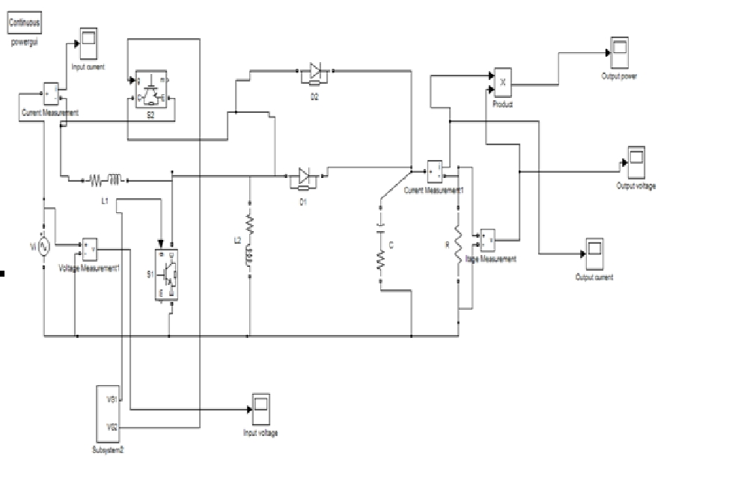

Fig 4 Circuit diagram for the energy harvesting converter

For the successful operation of this self-starting circuit, the battery nominal voltage Vb should be less than the target output voltage vo minus the forward voltage drop of a diode V_{f} and it should be above the minimum voltage requirements of the controller and driver circuits.
v_{b<}v_{o}-vf
In this paper, the target of output voltage v_{o}=3.3v and forward voltage drop of the diode v_{f}=0.22v. A battery with beginning of the converter operation, the circuit diagram for the implementation of the proposed energy harvesting converter and its control scheme is presented inFig.2.3. The sensed output voltage of the converter proposed by a low pass-filter. Proposed signal is compared with the reference voltage v_{ref.} The error signal is used by the PI controller to estimate the control voltage that it a saw-tooth waveform in the pulse width modulator (PWM). The pulse signal produced by the PWM is fed to the two buffers that can enabled by the external signals. The comparators in the polarity detector unit enable the appropriate buffers to produce gate pulses (v_{g1} andv_{g2}) that control IGBTs of the boost and buck-boost converter during appropriate half cycle.
C. Implementation

A prototype was fabricated to verify the operation and performance of the proposed converter. Commercially available components are used to realize the prototype. In this work, the resonance based electromagnetic micro generator is modeled as an ideal ac voltage source. A signal generator followed by a high current buffer is used to realize the micro generator input voltage. The buffer is made by using a power op-amp (LT1210 from Linear Technology) in voltage follower mode. The source amplitude and frequency were set to 400mV and 100Hz respectively. The output voltage reference was set to 3.3 V. The operating duty cycles of the converter are about 0.8
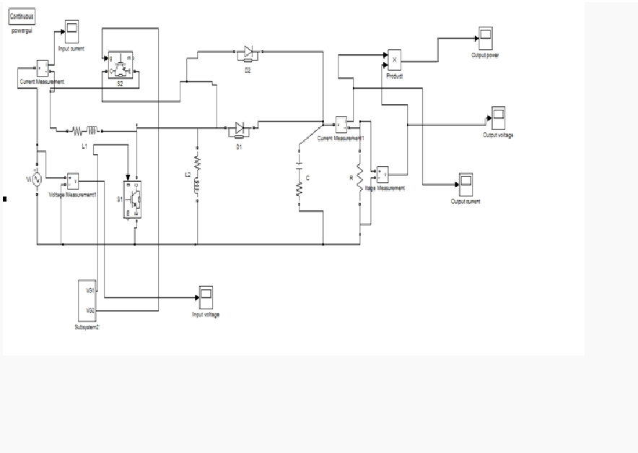

Fig .5 Circuit Diagram of the energy harvesting converter

Both the boost and buck boost converters are switched at 50 kHz switching frequency. This matches very closely with the earlier calculation and simulation results. It can be seen that the input current follows the profile of the input voltage. So with proper control strategy maximum energy harvesting can be successfully implemented. The output voltage is shown in Fig 8.5. It can be seen the low voltage ac input is successfully boosted to a well regulated higher dc voltage (3.3V). It was found that the duty ratio of the boost and buck-boost converter were almost same. The estimated efficiency of the converter was 61%. This matches with the duty cycle calculated from the earlier analysis of the simulation result. Hence the proposed scheme can successfully control the converter under different load conditions. In (fig7.5) measurement of the converter output voltage and battery voltage level during the start up operation of the converter output voltage are presented. It can be seen that the converter output voltage becomes higher than the constant battery level (3 Volts). The converter voltage remains the higher than the battery voltage. It is measured that the time taken to reach the startup point is about the 5 Milli Seconds. These measurements match closely with the simulation results presented in the previous wave form the required current could not be measured to estimate the startup power draw by the control circuit of the converter. To calculate the power losses in the various component of the converter the current in the component of the converter circuits were measured and the values of the parasitic components (See Table

No 7 ) were estimated the measured currents values were estimated. The measured currents voltages and estimated components values are used to calculate the loss components analytically.

Table No 7 Loss Calculations of Proposed Converter

Circuit |  | Estimated
Components | Name | Loss
Inductor | L₁, L₂ | 4.7mW,4.9mW
IGBT(boost) | S1 | 6.2mW
IGBT(buck-boost) | S₂ | 6.3mW
Schottky diode (boost) | D₁ | 2.4mW
Schottky diode (buck-
boost) | D2 | 2.5mW
Output Capacitor | C | 0.1mW

However, it is found that with the use of larger IGBT switch lower on state resistance (Rds_on) the efficiency can be further improved. IGBT with optimum on state resistance and gate capacitance value should be selected for minimum loss in the bidirectional switch.
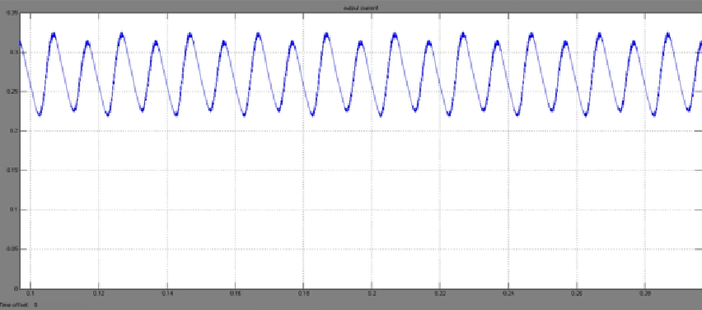

Fig 6. Output DC Current during self start up curve
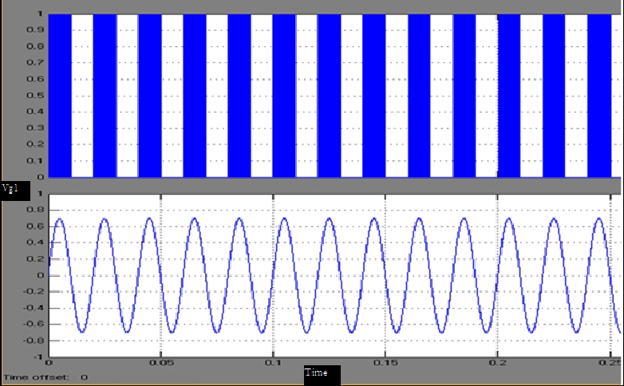

Fig 7 Vg1 is given to the Boost Converter
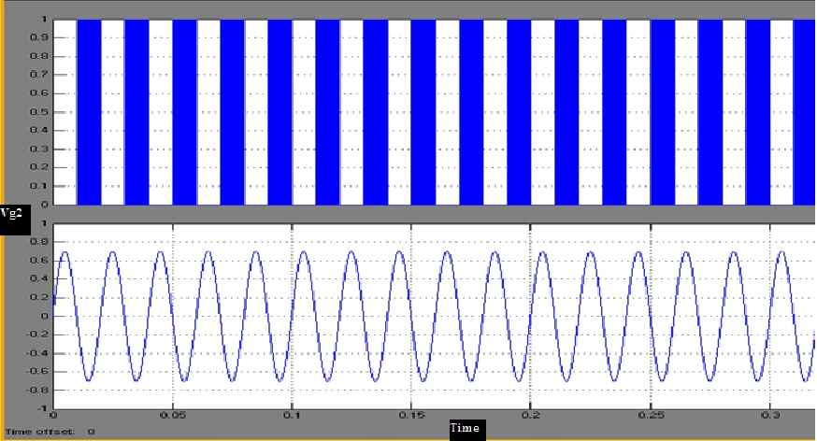

Fig 8 Vg2 is given to the Buck-Boost Converter
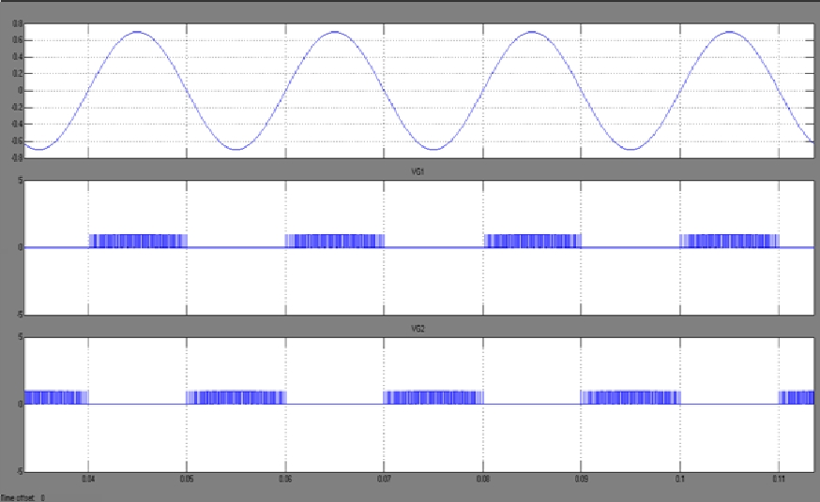

Fig 9 Input currents, gate drive signals and Input voltage during a switching cycle of the boost and buck-boost converter.

III. RESULTS

A resonance based electromagnetic micro generator, producing 400 mV peak sinusoidal output voltage with 100 Hz frequency is considered in this paper for verification of the proposed converter topology. The closed loop simulation of the converter is carried out based on the control schemes presented in this project. The reference output voltage (Vref) is considered to be 3.3 V the energy harvesting converter is designed for supplying power to a 200Ω load resistance hence supplying about 55 m W of output power.
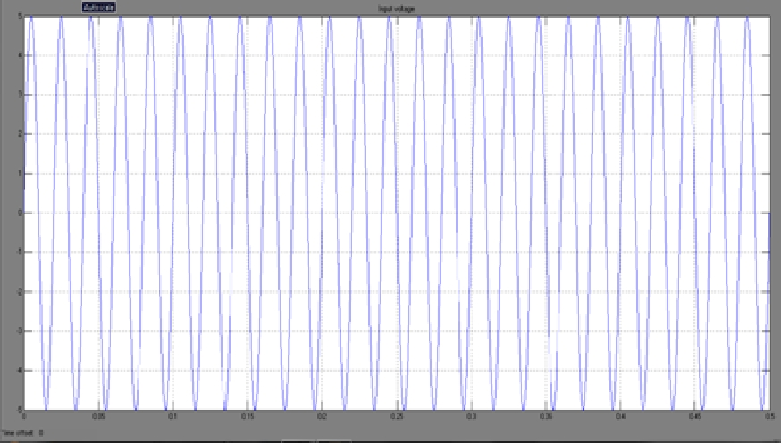

Fig 10 Input AC Voltage during self start up curve

The converter design is carried out based on the analysis and design guide lines. Commercially available IGBT is selected to realize the switches S1

and S2. The forward of selected IGBT body Diode is about 0.8 Volts, Which is higher than the peak of the input voltage. This inhibits any reverse conduction in the MOSFET’s. The inductor is designed to have a standard value of 4.7uH and commercially available inductor is used to realize L1 and L2. Based on this designed values the switching frequency of the converter is selected to be 50 K Hz. The diodes D1 and D2 are chosen to be Schottky type with low forward voltage 0.23V. The output capacitor value is 68uF. The converter simulations are carried out in Saber. Circuit model of the selected devices and components available from the manufacturers are used in the simulation. Various values for circuit components of the designed converter are presented in Table 1.1. The input current of the boost converter and the input current of the buck-boost converter for load resistance R=200Ω is shown in Fig 8.2.

It can be seen that the boost converter operated during the positive half cycle is shown in Fig8.4. While the buck-boost converter is operated during the negative half-cycle is shown in Fig 8.5 of the micro generator output voltage. It can be seen from these plots that at the beginning when the converter output voltage is building, the power consumed by the control circuit is only supplied by the battery is shown in Fig 8.6

IV.CONCLUSION

In this paper, direct ac-to-dc low voltage energy harvesting converter avoids the conventional bridge rectification and achieves higher efficiency. The proposed converter consists of a boost converter in parallel with buck-boost converter. The negative gain of the buck boost converter is utilized to boost the voltage of the negative half cycle of micro generator ro positive DC voltage. Detailed analysis of the converter for direct ac-to-dc, power conversion is carried out and relation between various converter circuits’ parameter and control parameter are obtain. The presented converter topology uses a boost converter and a buck-boost converter to process the input voltage positive half and negative half cycles. The converters are operated in DCM to reduce switching losses and for simple control. Operations of the converter were analyzed and two control strategies were proposed.

Using the control strategies, the converter was successfully controlled to boost the low voltage ac input to a higher dc output voltage with low ripple. The proposed converter can also be successfully used for maximum energy harvesting. The measured efficiency of the converter is 61% which higher than the reported converters. Simulation and experimental results validate the operation and performance of the proposed converter.

V.REFERENCES

- M.Ferrari,V.Ferrari,D.Marioli,and Taroni,”Modelling,Fabrication and Performance measurements of a piezoelectric energy harvesting in autonomous micro systems,”IEEE

Transaction instrum,measu,Vol.55,No6,pp.2096-2101,Dec 2006.

- J.A.Paradiso and T.Starner,”Energy scavenging for mobile and wireless electronics.”IEEE pervasive computing,vol.4,no.1,pp.18-27,Jan./Mar. 2005.

- S.Meninger,J.OMar-miranda,R.Amirtharajah,A.P.Chandrakasan,and J.H.Jang,”Vibration to electic energy conversion,”IEEE trans.very large scale integr.syst,vol9,no.1,pp.64-76.feb 2001.

- Mel-Hami,P.Glynee-Jones.N.M.White,M.Hill,S.Beeby,E.James,A.D.Bro wn,and J.N.Ross.”Design and fabrication of a new vibration based electromechanical power generator,”Sens.actuator asa:phys.vol.92,pp.335-342,2001.

- A text book of Electrical Technology byB.L.. Theraja and A.K. Theraja (volume 2).

- Power Electronics by Dr. P.S. Bimbra.

- Electronic devices and circuits by S Salivahanan, N Suresh Kumar, A Vallavaraj.

- Power Electronics by M.D.Singh,K B Kanchandani.

- “Energy scavenging for mobile and wireless electronics” by J.A.Paradiso and T.Starner.

- “Power processing circuits for electromagnetic, electrostatic and piezoelectric inertial energy scavengers,” by P.D. Mitcheson, T.C.Green, E.M Yeatman and A.S Holmes.

- “Adaptive Piezoelectric energy harvesting circuit for wireless remote power supply,” by G.K. Ottman, H.F. Hofmann, A.C. Bhatt, A.C. Bhatt, and G.A. Lesieutre.

VI.Authors Biography

Shaik Rafi Ahmed received his M.Tech degree from J.N.T.U in power electronics, he has been working as an assistant professor in EEE Department of Deccan College of engineering and technology. He did his diploma in Electrical&Electronics and B.Tech in Electrical and Electronics from J.N.T.U. Hyderabad. His current research interests Include power electronics, power converter and electrical drives.
Dr.Pannala Krishna Murthy, received his P.hD degree from J.N.T.U in power systems and power electronics, he has been working as Professor and Head of the department EEE in Swarna Bharathi Institute Of Technology. His current research interests Include power electronics, power systems, power converters and electrical drives.
Dr.Sardar Ali, received his P.hD degree from J.N.T.U.A in power systems and FACTS. Known is has working in Professor & Head of Dept, Royal instate of science &technology, Chevella.

